8.1.5- Inverse and Direct Variation Notes

Variation: | Direct | Inverse
Describes: | Directly proportional | Inversely proportional
Relationship between x and y: | Both increase or both decrease | If x increases, y decreases.  If x decreases, y increases.
Function Family: | linear | rational
Equation: | $y=kx$ | $y=\frac{k}{x}$
Example 1: Use the information provided to write an equation representing the given relationship.
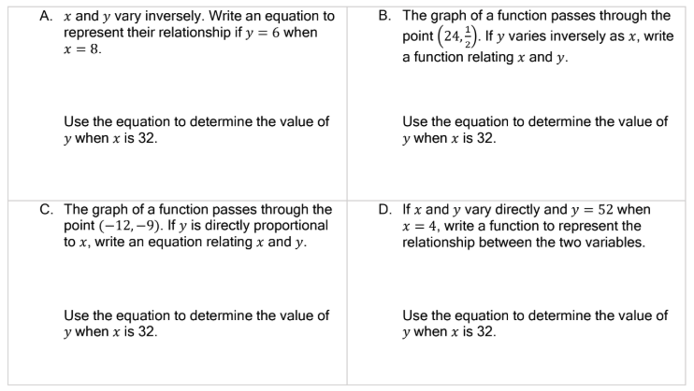
Example 2: Determine if the relationship between the data provided varies directly, varies inversely, or neither. Formulate functions to represent the direct and inverse relationships.
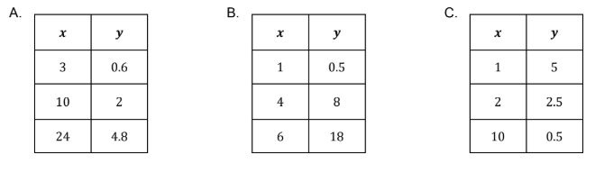

Example 3: An equilateral triangle with a side length of x centimeters has a perimeter of y centimeters. Write a function to represent the relationship between x and y.

Example 4: A local vineyard owner hired the local high school;s garden club to help pick grapes during the grape harvest. The vineyard owner will pay the garden club a flat fee of $400 to pick five acres of grapes, which will be divided evenly among each member that shows up to help pick grapes.
- Formulate an equation relating each person’s earnings to the number of garden club members picking grapes. Let x = number of students and y= earnings per student ($)

- How much did each student earn if 15 garden club members helped pick grapes?

- How many garden club members participated in the grape pick if each student earned $57.14?

